**1. Create an S3 Bucket**

* **Step 1**: Go to the **S3 Dashboard** in the AWS Management Console.
* **Step 2**: Click **Create bucket**.
* **Step 3**: Enter a unique bucket name (e.g., my-secure-bucket-4556) and choose the desired region.
* **Step 4**: Configure any additional settings as needed and click **Create bucket**.

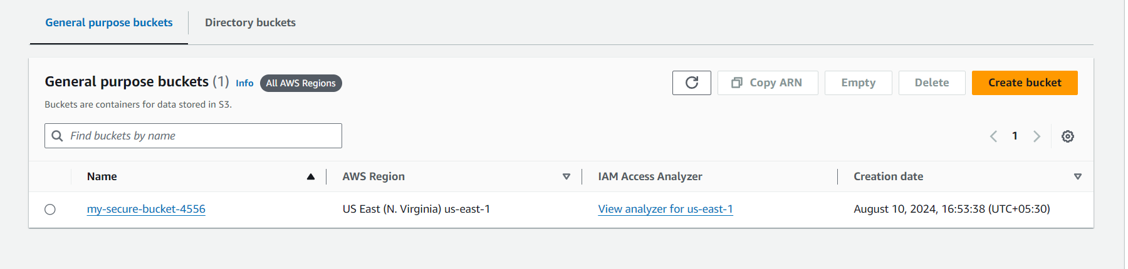

**2. Create a VPC Endpoint for S3**

* **Step 1**: Go to the **VPC Dashboard**.
* **Step 2**: In the left navigation pane, click on **Endpoints**.
* **Step 3**: Click **Create Endpoint**.

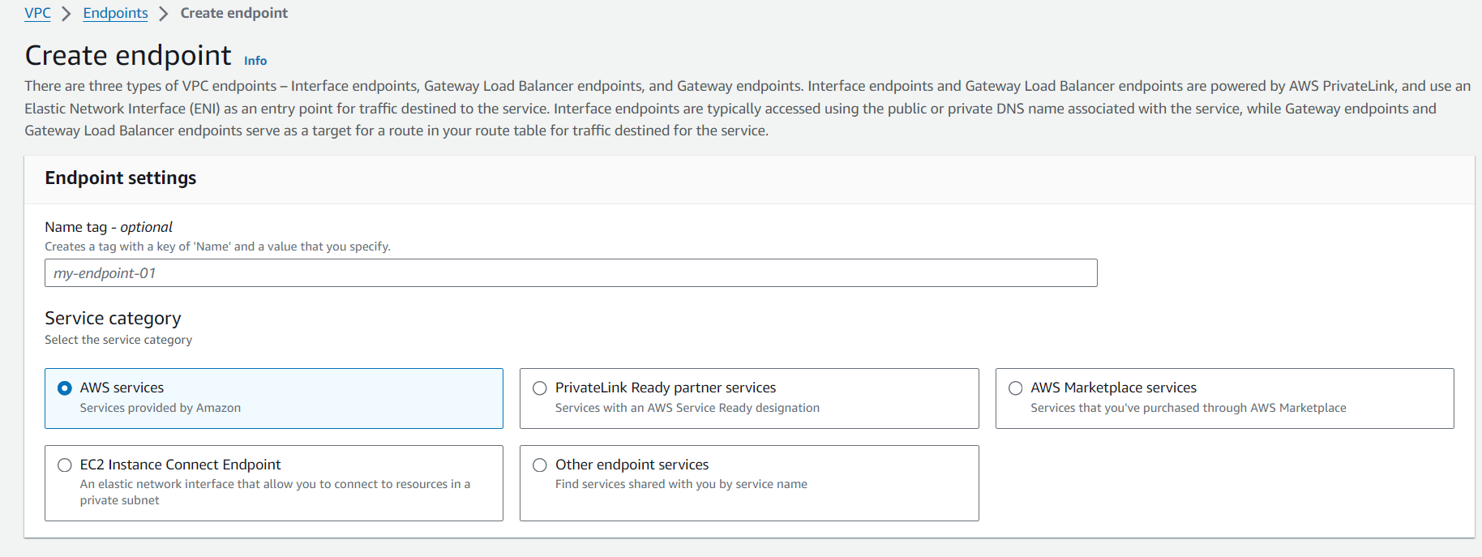

* **Step 4**: Select the **Service Category** as "AWS services" and find the **Service Name** for S3 (i.e. com.amazonaws.us-east-1.s3).

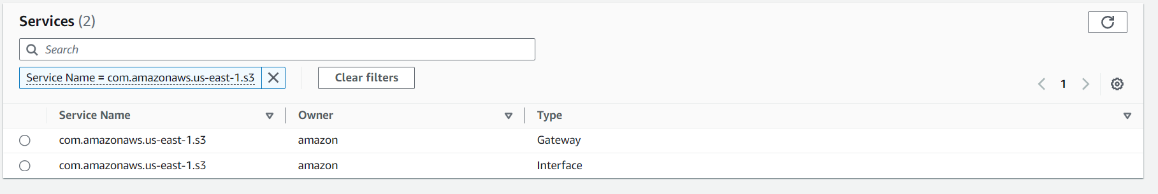

* **Step 5**: Configure the VPC endpoint:
  + **VPC**: Select the VPC where you want to create the endpoint.
  + **Subnets**: Select the subnets in which the endpoint should be accessible.
  + **Security Group**: Optionally, choose a security group that allows access to the S3 bucket through this endpoint.
* **Step 6**: **Policy**:
  + You can either choose the **Full Access** policy

**4. Test the Configuration**

* Access the S3 bucket from an instance within the VPC, ensuring that the S3 requests are routed through the VPC endpoint, ensuring secure and private access.